TCL EMAIL LOG IN INSTRUCTIONS

To sign in to your TCL email account, access the Windows Live Hotmail Sign in prompt at http://mail.live.com.

If you need assistance with your Windows Live ID or Password, contact the TCL Help Desk at 843-525-8344 or helpdesk@tcl.edu.

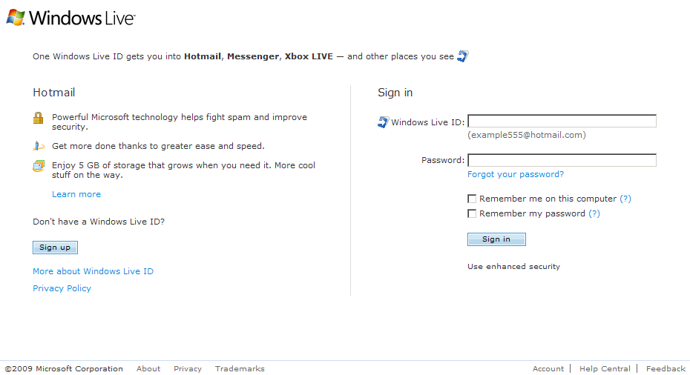
Your initial Password is the last seven digits of your social security number

firstnamelastname@my.tcl.edu
(typed in lowercase letters with no spaces)

Click on Help Central for technical assistance.
NOTE: The TCL Help Desk cannot reset your password.
For security purposes,
DO NOT CHECK THIS BOX.

DO NOT CLICK “Sign up”.

