Microsoft Word 2007 Features for MLA Style Reports

To begin your report, complete the four numbered steps below in the order provided. Be sure to save your file frequently.
1. Set the margins to 1 inch.
- Click the Page Layout tab, then Margins.
- Choose Normal, which will change all margins to 1.”
2. Create a header to display your last name and the page number.
- Click the Insert tab, then Header.
- Choose Blank.
- Your screen will look like this:
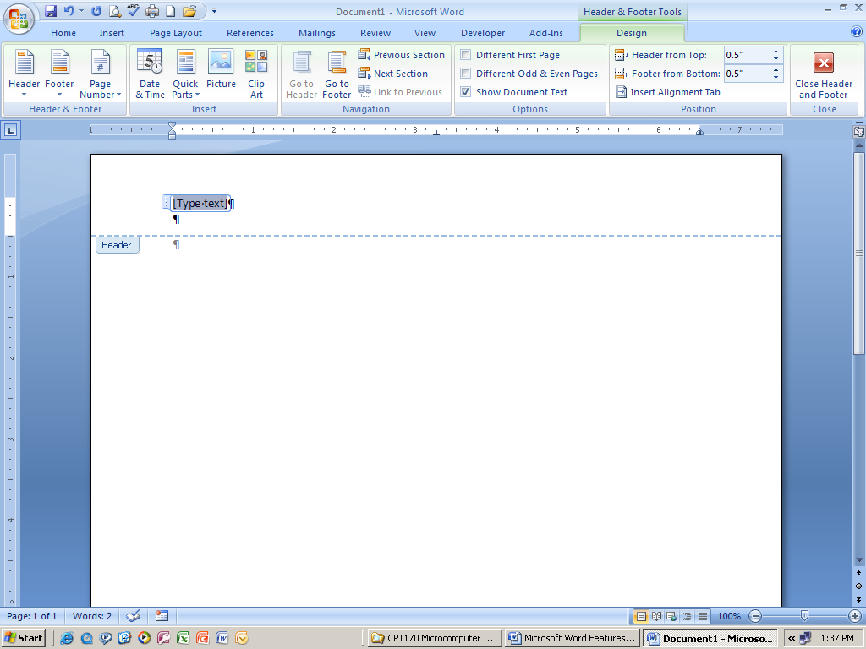

- Click the “Type Text” placeholder and hit the tab key two times. Now your insertion point should be blinking on the right side of the Header box and the placeholder has disappeared.
- Type your last name and hit the space bar one time.
- Click the Page Number button and choose Current Position, then Plain.
- Click the Close Header and Footer button on the ribbon to begin typing your report.
3. Set the line spacing to double.
- Click the down arrow connected to the Line Spacing button in the Paragraph grouping on the Home tab.
- Select 2.0.
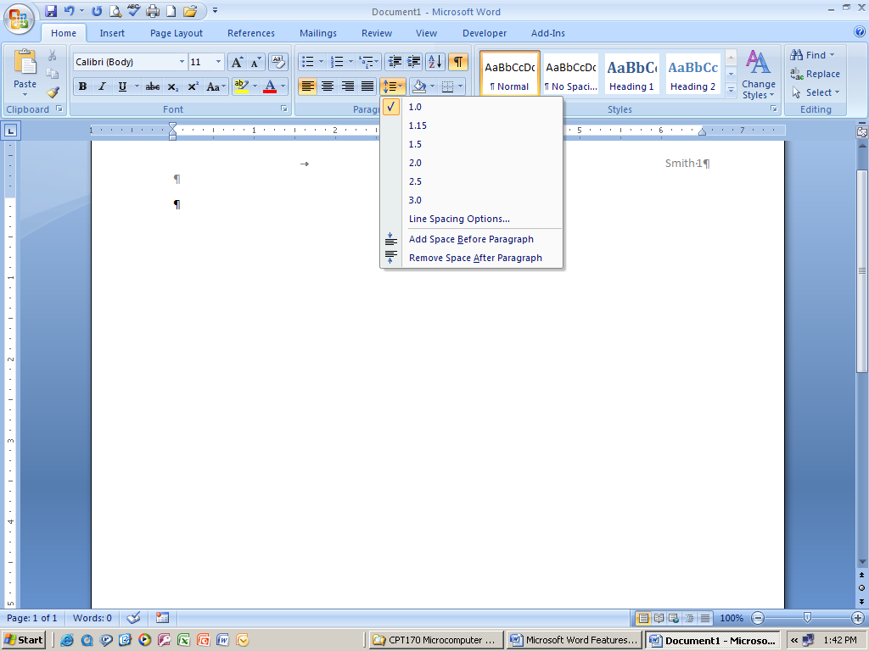

- Click the down arrow connected to the Line Spacing button a second time and choose “Remove Space After Paragraph.”
- Type your four-line heading at the left margin—hit enter after each line.
- Click the Center Align button, type your report title. Hit enter once after the title.
- Click the Align Left button.
4. Set the Indent Marker for the paragraphs.
- If you do not see your ruler, click on the View tab, then put a check mark in the Ruler box.
- Point to the First Line Indent Marker on the ruler. When you see the screen tip “First Line Indent,” click and drag the marker to the ½” mark on the ruler.
- These steps should be completed before typing the first paragraph.

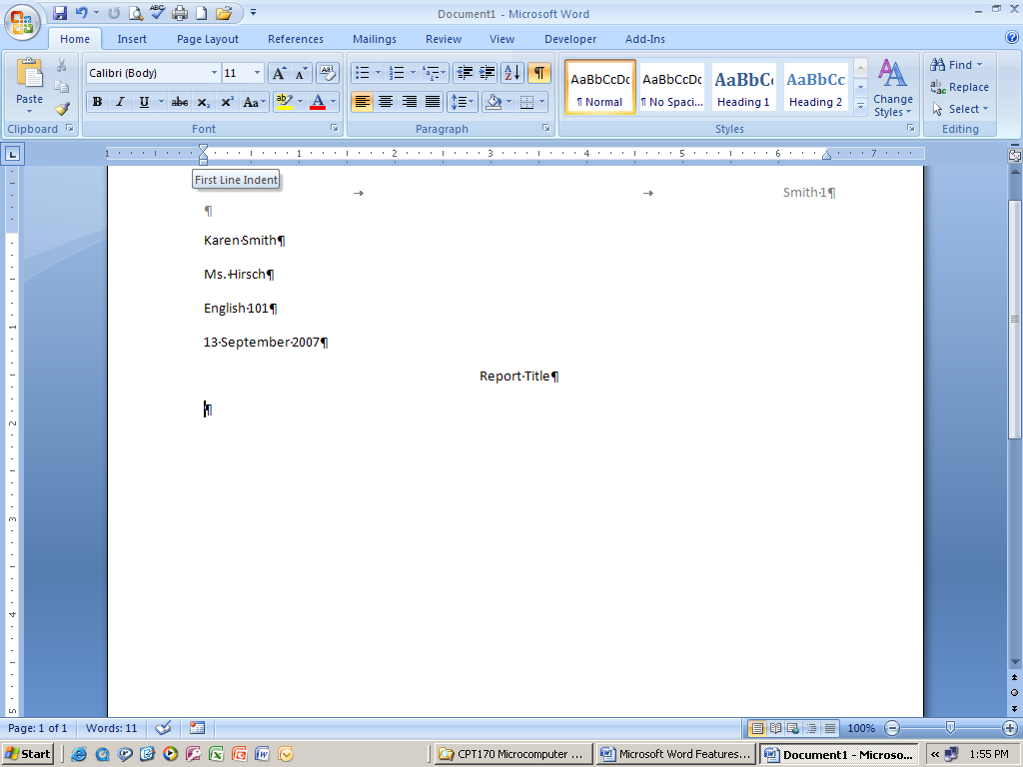

- Use the Word Wrap Feature when typing the paragraphs of the report. This means that you do not press the enter key until the end of the paragraph. The computer will know when a word cannot fit on one line and will wrap it to the next line for you.

Use the remaining instructions as needed.
Steps for creating and inserting a new Citation:
- Click the References tab.
- Be sure the style is set to the type of report you are creating—either MLA or APA.
- Click Insert Citation, then Add New Source.
- Choose the type of source you are citing.
- Fill in the boxes as required by your instructor or as indicated in your Keys for Writers handbook. If you are not seeing a required field, click in the box in front of “Show All Bibliography Fields.” You should now be able to locate the field(s) you need.
- Click OK when all required fields are filled in.

Adding Page Numbers to a Citation:
- Click on the citation within your report.
- Click the list arrow attached to the Citation Placeholder.
- Choose Edit Citation.
- Type in the page number(s).
- Click OK.

To Hide Text (such as an author’s name) appearing in the Citation:
- Click on the citation within your report.
- Click the list arrow attached to the Citation Placeholder.
- Choose Edit Citation.
- In the Suppress section, click in the box pertaining to
the text you want to hide (suppress).
- Click OK.

Steps for inserting an existing Citation:
- Click the References tab.
- Be sure the style is set to the type of report you are creating—either MLA or APA.
- Click Insert Citation.
- You will see your existing citations listed--click on the one you want to insert.
- If necessary, follow previous steps for adding page numbers or suppressing text.

Steps for Inserting Footnotes:
- Click on the References tab, then Insert Footnote.
- A raised number one will appear in your document at your insertion point, and a dividing line with a raised number one will appear at the bottom of your document.
- Type your footnote at the bottom of the page.
- Before typing the period at the end of the footnote, use Insert Citation on the Research tab to insert the page numbers in the footnote, then type the period.

Steps for Inserting Page Numbers in the Footnote:
- Use the steps provided previously for inserting a new or existing citation and for adding page numbers to the citation.
- You will need to format the footnote according to MLA or APA style. For example, when using MLA style, the footnote should be double spaced, indented ½”, and have the same font/font size that is being used in the report—most likely Times New Roman, 12 pt.

To Format the Footnote according to MLA style:
- Right click anywhere in the footnote; choose Style, then Modify to open the Modify Style Dialog Box.
- Change the Font and Font Size so that it is the same as what you used in your report.
- In the bottom left corner of the Modify Style Dialog Box, click the Format button, then Paragraph.
- Under Special, choose First Line (the “By” should automatically change to 0.5”).
- Change the line spacing to double.
- Click OK, then OK again, then Apply.
- Your footnote should now be formatted correctly.
To Delete a Footnote:
- Select (highlight) the raised number in the text of the report.
- Hit the delete button on the keyboard.
- The footnote will be gone, and Microsoft Word will adjust the numbering of the other footnotes if necessary.

Steps to create a Works Cited page for MLA style reports:
- Hit Ctrl + Enter on your keyboard to insert a manual page break.
- Be sure that you are positioned on the new, blank page.
- Move the First Line Indent marker on the ruler back to the left margin.
- Click the Center Align button (on the Home tab) and type “Works Cited” for an MLA report or
- Hit enter one time and click the Left Align button.
- Click the References tab.
- Click Bibliography, Insert Bibliography.

To Format the Bibliography (Works Cited for MLA):
- Click anywhere in the list of sources. All sources will be highlighted in gray.
- If necessary, click the Home tab.
- Click the Styles Dialog Box Launcher to display the Styles task pane.
- Click the Bibliography list arrow and choose Modify.
- If necessary, change the Font and Font Size so that it is the same as what you used in your report.
- Click the Format button, then Paragraph.
- Under Special, choose Hanging (the “By” should automatically change to 0.5”).
- Change the line spacing to double.
- Click OK
- Click Automatically Update, then OK, then Apply.
- Close the Styles task pane.
- Your Works Cited/References page should now be formatted correctly.

To Modify a Source and Update the Bibliography for MLA style reports:
- Click the References tab, then Manage Sources.
- Click the source you wish to edit in the Current List.
- Make any changes you wish and click OK.
- If a Microsoft Office Word dialog box appears, click its “Yes” button to update all occurrences of the source.
- Click Close in the Source Manager dialog box.
- Anywhere in the report where the source was used, including the Bibliography, should be updated with the new information.

